**Computing Project**



**ICON College of Technology and Management**

**Faculty of Information Technology and Engineering**

**B SC (Hons) Computing-Top Up**

**Unit 610: Computing Project**

**Smart City – Pollution Monitoring**

**Tutor: Dr. M. J. Hassan**

**Costin Alexandru Pescaru**

**ID No.: 14887**

**February 2021**

**Summary**

In large cities, air pollution can be reduced by a period of up to 22 months. However, according to a study conducted by the World Health Organization (WHO) in May 2016 and reviewed in 2018, many major cities are facing this problem. More than 82 percent of urban areas have higher levels of air pollution than acceptable levels; “An estimated more than nine hundred thousand individual’s loss their lives each month because they come into contact with microscopic particles, which cause strokes and heart attacks. Lung cancer and respiratory diseases. "The World Health Organization provides an interactive map for measuring positive particles (PM2.5) in micrograms per cubic meter. New methods have been used to track and control CO levels. LIVE all the DATA To improve this method, each sensor has a battery powered by a solar panel. The idea of ​​this method is that everything has an ECO cycle and does not require expensive building materials.

An indoor / outdoor carbon monoxide analysis system, consisting of a "Smart-city" carbon monoxide sensor and data store, is displayed. The data store depends on 4G and 5G to evaluate the amount of carbon monoxide in air. Smart-city system was designed on the basis of 4G/5G technology to help in monitoring amount of carbon monoxide and transmit data to a data centre through LTE at a faster rate. This system composed of Human control centre, Internet connection, Cisco Packet Tracer (Simulation of Cisco Packet Tracer), PC Desktop / Laptop, CO2 sensor, CO Sensor, Laser Dust Sensor, Arduino, Heat-Moisture Sensor and Cloud-based cloud computing

In this system, the device was developed to determine amount of CO present in the atmosphere. This system has been piloted for its accessibility as set by ministry of environment. This system was designed to amount of monitor carbon monoxide in air. Therefore, network manager can examine amount of carbon monoxide in air at anywhere they are, through a server or application. The server or data stores contain all the details in the internet to retrieve all the detail of CO in the atmosphere. The system has been designed to demonstrate the feasibility.

Table of Contents

Introduction 5

Aim of the project 6

Objectives 6

Background information 6

Scope of the project 7

Project Requirements: 7

Literature Review & Background 8

Methodology 10

Waterfall Model 10

Agile Model 12

Rapid Application Development method (RAD) 14

Project strategy 16

Risks of system development 16

Project plan 16

Gantt chart 16

Advantages of Gantt Charts 17

Work breakdown structure 19

WBS construction 19

Defined Work Breakdown Structure 19

Project build: 20

Specification 20

Design: 22

Why I chose those parts: 22

Evaluation of different technology: 22

Implementation: 24

Hardware Implementation: 24

Circuit connections 24

Circuit Diagram explained: 25

Software implementation: 25

I used the following libraries: 26

Final Code (the code provided below its attached in appendices as well): 29

Result and Evaluation 31

Conclusion 33

Future work 34

Reflection on Learning 35

References 36

Appendices 37

Logbooks: 37

Ethical Form: 37

Power Point Presentation 37

Arduino Code 37

***Smart City – Pollution monitoring***

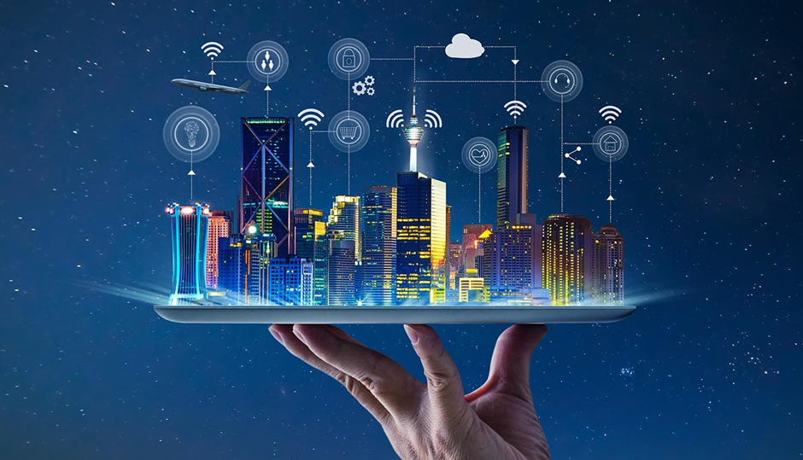

# Introduction

Ozone layer is increasing in alarming rate every time as a result of high population growth, this leads to increase in pollution in the atmosphere. Being that air is the main source of life, larger number of individuals in these polluted areas has vision problem. Some of these pollutants are water, soil, noise, heat and air pollution are very dangerous of all, this causes a greater change in climate change and diseases which interfere with life. The research which has been done by World Health Organization (WHO), shows that more than 90 percent of population breathes contaminated air, and air contamination is causing of more than five hundred thousand lives every month. Effects of pollution on health is very dangerous, it causes diseases such as heart disease, lung cancer and stroke. In addition, pollution in air pollution has devastating effect on humans and its environment, as seen in the past pollution on air which has effects such as reduction of the ozone layer. however, the amount of air should check and quick action taken. According to ministry of environment, indoor air is more than 99 times polluted than atmospheric air. A larger number of populations today take between 80 and 95 percent of their time in houses; therefore, indoor air causes more effects to human than outdoor air. In addition, unlike pollution in the atmosphere, indoor pollution is nearly hundred times likely to be taken by lungs, causing diseases such as building-up syndromes, higher chemicals sensitivity and dizzy in human. Management of air quality is very crucial, as it leads to protections and exposures through the use of precaution measures. Therefore, to monitor and efficiently manage air quality is very important.

The reduction emitted pollutants, new method has been developed, which includes the design of air measuring equipment / tool air purifier devices. Results show that only devices can provides accurate air quality readings for indoor. research by the Department of Environment recommends that low reliable of air quality measuring values on multiple equipment depend on numbers of factor which includes measuring methods, equipment configurations and transfer of data. Therefore, technological advances in the amount quality air monitoring areas should be designed in line of the need for more accurate monitoring device.

The introduction of Internet of Things (IoT) and cloud computing technologies revealed that new real-time examining capabilities in different fields or areas. Therefore, researchers have studied the integration of such technologies into the smart city. However, these studies focused only on the integration of IoT platform construction to monitor air quality in real time. As technology embodies, wireless sensor networks to enables the transmitting, processing, analyzing and visualizing of data, integration of these new technologies may also offer significant benefits in improving indoor air quality.

Indoor air qualities monitoring platform based on integration of cloud computing and IoT are provided. Smart-city was designed to accurately examine quality of indoor air and effectively transfer real-time information to computer-based internet servers by the use of IoT sensor networks. A computer-based internet server is introduced on this system to analyze real-time information to show indoor air quality conditions. In addition, internet servers are developed to give alerts to facility administrators to measure poor air quality so that affected companies can take quick action.

## Aim of the project

Its main purpose is to collect, analyze and process data obtained from sensors to obtain real-time monitoring of carbon monoxide air quality and to determine the safety and consistency of the data collected.

And to decide how the 5G network can be used to monitor and test any type of pollution in cities.

## Objectives

* To use Smart-Air to accurately monitor indoor/outdoor carbon monoxide air quality.
* To use IoT to properly monitor real-time data
* To discover cloud computing with real-time indoor carbon monoxide air quality analysis.
* To improve the type of sensors or data collection devices and provide resource management information.
* To develop a system used for the monitoring and management of traffic and transport systems, waste disposal, drainage networks, and other public services.

## Background information

Building this project requires a lot of sensors that get CO in the air. We will have the whole city those sensors installed in the right places as my sensors will attach a small size solar panel to power the sensor and the battery that will keep the sensor on at night. This device will have a size of 300-400cm3 which behind me is a large tool and can be easily installed anywhere. I take this as one of the problems as I try to be friendly to ECO as this is the main purpose of this project.

Another issue with my project will be long battery life as initially the battery will last a few months, but even a normal phone loses battery life for the rest of its life. This means that our system will have some battery problems every few months when the system will not be powered by the solar panel and will require a few months service to prevent major failures.

The best part about this system is that it can attach more sensors to things like moisture. It is fitted with a variety of polluting sensors for smart city projects. The solution was applied to different cities, and 17 sensors were installed on buses. New to these approaches lies in the functioning of the senses and the intentions of the platforms to use measurement platforms and dashboards to provide maps. A sample of the collected data can be found. The problem with this type of system, is that it is not ECO friendly because it uses motor-powered power over potential objects and DATA is inaccurate as those vehicles change position frequently. As in 1, I think it is a better idea to use solar panels to maintain electricity consumption and it is a static and accurate data can be obtained as it has a static space that can be compared with preview days / hours.

## Scope of the project

The scope of this project is to create a traffic control system based on CO levels in the city. As the design is simple and intended to use Wi-fi connectivity to send LIVE - DATA to the Cloud Platform located at the traffic control station so everything can be expected to be much easier for traffic to be redirected according to the data collected. One major advantage of the system, it can be unlocked in the automated process without human control.

As if those detectors were plugged into the robots and connected to the robot, then it would be much easier to redirect traffic based on a simple algorithm, but still it would still have to look like the sensor failed, lost communication or something electrocuted could cause catastrophe on a large scale. I mentioned one of the shortcomings of this system is the power source as those machines work with solar panels and a built-in battery to be used at night, but still, I think it would be wise to connect to a power source Traffic light as protection in the event of a power detector failure. Another advantage of installing this system on robots is that the closer the point where the CO density is higher and as such it will be easier to control traffic.

The city's Smart system aims to ensure total pollution in cities through 5G network technology. The study will be conducted in cities where pollution is rampant which will ensure that all cities are free from any form of pollution.

## Project Requirements:

Internet connection

PC Desktop / Laptop

Microcontroller such as NodeMCU

Gas Sensor

GPS Module

Breadboard

Jumper wires

USB cable

Cloud-based cloud computing

Breadboard

# Literature Review & Background

Literature reviews related to a selected project, identifying a topic or product limited to reach its potential, suggesting you develop or produce a product that complements the specifications specified in your project scope, after the problem, the books will also contain reviews of the same project in the market and may contain market research.

Consideration will also be given to the work done by others in connection with smart technology or pollution. The problems encountered are those authors and possible solutions.

Pollution is increasing at an alarming rate every day. Air is a very sensitive organism that is temporarily polluted by airborne substances. Knowing the levels of air pollution, air quality this suggests that the system is a network of wireless networks that are most active in monitoring pollution occurring in smart cities. Its low budget monitoring system with simple but efficient and very accurate sensors.

Some operate as a Smart Environmental Protection System [(Jamila.S, 2o15)] in the transportation sector launched in 2015. It basically detects the emissions of toxic gases that cause air pollution. Industrial air pollution monitoring program [(Leman.A.M, 2010)] was established for the purpose of safety and health improvement to identify harmful gases and their effects on the environment. The low-level air system [(Kularatana.N, 2008)] was discussed in 2008 because at that time nerves were too expensive to use. With GPRS systems [(Al-Ali, 2010)], air pollution was not detected. Wireless network monitoring systems were introduced

know the amount of air quality [(Raispure.S., 1998)]. Pollution Monitoring System [Boscolo, A., Mangiavacchi, C. (1998). The City's Air Pollution Control Air Quality Control System has been developed much earlier.

In reviewing the future, a previous study. It can be concluded that air pollution has increased at alarming rate. If not properly managed it can cause severe deaths in future. Such pollution areas are water, noise, plastic and soil pollution. We can conclude that air pollution are very serious problems, this can be studied in order to protect the planet.

According to the World Health Organization: WHO, smoke billowing from cities smokes indoors, air pollution poses the greatest threat to biodiversity and climate. The effects of the combination of air pollution in the ambient (outdoor) and in the home cause about five hundred thousand premature deaths per month, most notably as an effect of increased deaths from respiratory diseases and respiratory infections. About 85% of individuals living in cities, monitoring amount air pollution is exposed to low levels of amount of polluted air that exceed the WHO guidelines, where developing countries suffer the most.

Major external sources of pollution include automobiles, generators, heating systems, agriculture or waste management and industry. In addition, an estimated 3 million people worldwide rely on polluted technology as well as domestic cooking oil, heating and lighting, home exhaust and outdoor pollution.

About 8.5 percent of the world's population inhale contaminated air. To reduce this, amount of polluted air should therefore be introduced into green energy.

The World Health Organization estimated that in some cases, only pollution caused 4.2 million deaths in 2015, while households polluted the air with oil-based cooking and technology that caused an estimated 3.9 million deaths at the same time. Therefore, ideas are being developed to create such programs that will inform people of the amount of toxic air breathed. Making such devices portable and easy to install is a great idea. Android device users and internet users have increased dramatically.

Wireless distribution devices, such as smart city uses General Packet Radio Service (GPRS) sensors according to [Al-Ali, A.R., Zualkernan, I. and Aloul, F., 2010. GPRS sensor cell list

to monitor air pollution. IEEE Sensors Journal, 10 (10), pp. 166-1671.]. Advances in wireless communication and sensor technology change monitoring rapid air pollution [Snyder, EG, Watkins, TH, Solomon, PA, Thoma, ED, Williams, RW, Hagler, GS, Shelow, D., Hindin, DA, Kilaru, VJ and Preuss, PW, 2013. Changes air pollution control.]. The Internet of Things (IoT) can allow for smarter surrounding where objects interact to each other [(Mathew, 2018)]. This system provides user with information about their personal exposure to air pollution.

Recursion Converge Quartiles (RCQ) algorithms used developed to improve efficiency and wireless air pollution control systems. The Recursion Converge Quartiles (RCQ) algorithms consolidate and eliminate duplicate data by removing invalid output. This helps to saving the large amount of energy. Sensor terminals which automatically collect information and transmit it to the network data center. Kmeans were developed for integration of an algorithm to monitor air pollution. The authors submitted that the proposed K-means clustering algorithms yielded prices directly during the few processing sessions compared to other existing strategies. Authors in

[Sammarco, M., Tse, R., Pau, G. and Marfia, G., 2017. Geosocial searches are used to monitor urban air pollution. Pervasively and.] Proposed model showing a focus on air pollution in real time. An appropriate solution has been developed. In Communications, Processing and Their Requests (ICCSPA), the first 2013 International Conference (pages 1-5). IEEE.].

Investigators Nayak, also developed IoT air-based pollution monitoring system over internet that creates warning at any time air quality goes below the normal.

# Methodology

This introduces how the system will be implemented and by which suitable method. It has the following, waterfall, agile and rapid application development.

## Waterfall Model

The name Waterfall is derived from the word flowing water and there is no way back. This method was developed primarily for use in software development companies. This type of software development method is divided into independent environmental categories.

In this way the release of one phase leads to the installation of the next phase which is why the next phase cannot start before the end of the first stage.

The following are the phase:

* Gathering of Requirements and analyzing
* System development
* System Implementation
* System Testing
* System Deployment
* System Maintenance

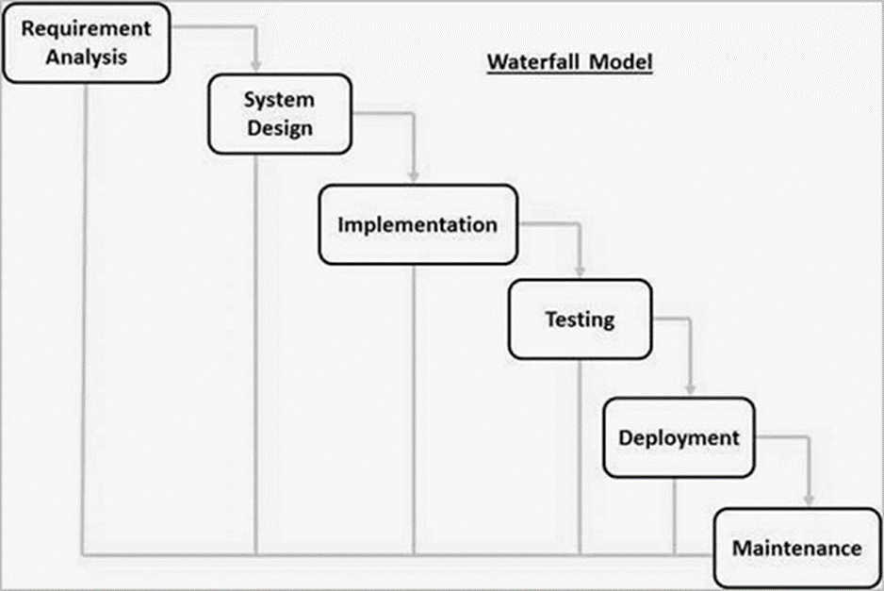

**Gathering of Requirements and analyzing** - this is the initial phase of this method. All system development requirements are collected and fully analyzed when everything is done in the correct form.

**System Design** - analysis in the first phase is done, all specifications are planned and system configuration is done. The design helps define hardware and system architecture.

**System Implementation** - of this phase, inputs from program design are used to develop small units of programs embedded or integrated. Every program is developed and later tested for performance in a process called units testing.

**System Testing** - the implementation of developed unit is put together after testing and ensures that they all work according to requirements, this is done to check for any failures before being deployed to the system.

**System deployment** - after integration and testing is done, all active and inactive tests, the product is released to the user environment.

**Maintenance** - after delivery, customers suggest issues to be fixed. These issues are fixed and released to customers. Maintenance is usually done to bring about changes suggested by customers.

The above categories are interdependent where progress is seen as slower and slower. The next phase begins only after the stated objectives have been achieved in the previous phase in this model, there is no overlap of categories.

|  |  |
| --- | --- |
| **Advantages of Waterfall Model** | **Disadvantages of Waterfall Model** |
| Simple and easy to understand as it can be used by anyone who develops a program. | No software production works until late during the life cycle. |
| It is easy to manage as each section has a specific submission and review process due to its robust nature. | A large amount of risk and uncertainty are involved as one phase must be completed to move to the next phase. |
| Each phase is processed and completed one at a time to ensure that all requirements are met. | It’s not a suitable model for complex projects and focused on an object as all categories depend on each other. |
| With the construction of a small project, it works well as the requirements are very well understood. | It cannot be used to develop long-term ongoing projects due to its complexity. |
| It has a well-defined section as there is no way one can easily forget. | Cannot be used for projects where the requirements are not well stated. |
| Problems are well understood as the result of one phase is used to magnify the next phase. | It’s not easy, in terms of measuring progress in stages as each phase depends on each other, |
| All requirements are easily planned before the start of the project. The whole process and the results of each phase are well documented. | Can't accept changing requirements as it is ready. |

## Agile Model

Its combination of iterative and incremental model. It is focusing on process of adapting and satisfaction customer by ensuring fast delivery of a functional product. It breaks the product into smaller growing units that provide for duplication.

Every iteration usually has time allocated by the project manager and the whole iteration involves the crossing of work, groups working concurrently in different areas.

At the end of every iteration, active products are sent to major customers and stakeholders.

In this model, all projects must be treated at different areas and the existing method needs to be developed progressively in line with the needs of the project.

This model requires that all operating software be delivered after every iteration, the tasks are separated by time boxes that bring in certain release features.

It is divided into progressive builds according to the factors in which the final construction has the characteristics.

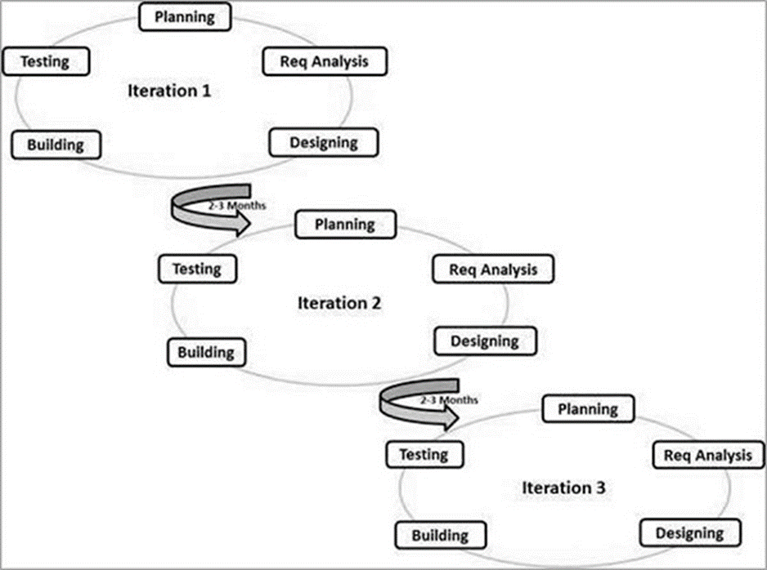

The Agile model has the following guidelines:

**Individual and interaction** - In this model of development, self-organization and motivation are central, as all communication is available in partnership with pairing programs.

**Working software** - software of some kind is considered to be the best way of communicating with customers and understand their requirement, rather than relying on documents.

**Customer’s collaboration** - in this model, needs cannot be fully collected at the beginning of a project for a variety of reasons, continuous customer communication is critical to finding the right product needs.

**Responding to changes** - this model needs to focus on improvement in rapid response to change and continuous improvement.

|  |  |
| --- | --- |
| **Advantages of Agile Model** | **Disadvantages of Agile Model** |
| It is the most sensible method used for software development. | Its content is appropriate for complex management and project dependence. |
| It promotes collaboration and opposite training as it all requires collaboration. | Its most dangerous methods of stabilization, maintenance and stretching. |
| With the involvement of iteration groups, all performance can be improved quickly and demonstrated. | Strict adherence to requirement controls the size and performance to be delivered, adjustment to meet the deadlines. |
| Requires minimal resources to upgrade. | It depends very much on the customers feedback, and if the customer gives wrong information, the whole project fails. |
| Suitable for planned or flexible needs for consumers. | There is high dependency on the individual, because there are fewer or no documentation. |
| It easily delivers partial performance solutions to customers. | Transferring this technology to a new team members can be quite challenging due to lack of records. |
| It has some rules, which make the text easier to use, |  |

## Rapid Application Development method (RAD)

This method is based on iterative and prototype types of development and tertiary design with the intangible planning involved. Software writing processes includes planning required product development.

It’s based on collecting customers need through workshop or focus groups, early testing of prototype by customers using the concepts of replication, reuse of existing prototype, continuous integration and faster deliveries.

It uses minimal editing according to the fastest way to display objects. The prototype is a functional model that works in parallel with the product component.

Performance modules are similarly developed as examples and integration to make a complete product delivery faster. This method does not require detailed planning, it makes it easy to include changes within the development process.

The following figure describes in detail the RAD Model.

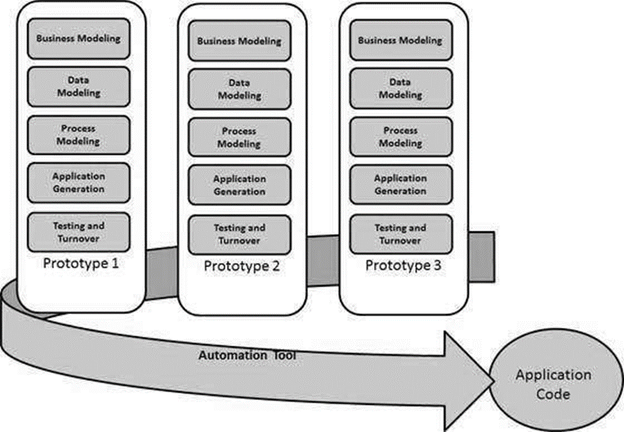

Various categories of Rapid application Development method

**Business Modelling -** It is built on the flow of information and information distributed between various business channels. complete business evaluation is done to obtain most important business information, and how it can be gotten and when the information will be processed and what factor drives the flow of effective information.

**Data Modelling -** Data collected is gathered and evaluated to create clusters that are less dynamic in the business. The attributes of all data set are visible and defined. Relationship between these data object is established and defined in details in accordance with the business method.

**Process Modeling -** Defined data set is modified to establish the flows of business information required in achieving certain business objective in a business manner. Process model for any changes or enhancements to data item sets is described in this section. Processes described are added, deleted, retrieved or converted to a given data object.

**Application generation -** This is where the real systems are built and coded using automated tool to convert processes and data models into the prototypes.

**Testing and Turnover -** Reduce the duration of the prototypes test as it is tested independently throughout the iteration. Multiple system tests have already been performed and tested, minimizing the risks of any major issues at this phase.

|  |  |
| --- | --- |
| **Advantages of RAD Method** | **Disadvantages of RAD Method** |
| Changing needs can be easily met. | It depends on a very strong technical team members to identify the needs of the business. |
| Progress can be measured in this model as it has its own version. | It only works on systems that can be modularization and built using RAD |
| Group exchange time can be shortened using powerful RAD tools. | It requires highly skilled engineers / designers as it is very expensive and complicated. |
| It is very productive with a few people in a short period of time. | Its high relies on Modeling skills. |
| Reduce development time due to prototypes. | It does not apply to cheap projects as it is very expensive in modeling and the automatic coding is very high. |
| Increases the reuse of elements within the system. | The management and maintenance of it is even more complicated. |
| The first update is possible. | Requires user involvement throughout the life cycle of the system. |

# Project strategy

A project strategy is a course in a project that contributes to the success of a project in its ecosystem. Is the project area, strategies and solution and how to do it, to get the best profit and the biggest profit from the project? (U-Artto, et al., 2008)

For this project we have decided to use the Waterfall Development Method, as it is at the forefront of this small project that we need to improve. My team members and I are not very experienced in designing software's, which is why we need to devise a systematic approach, with specific steps and specific requirements to create appropriate software for the library. This approach has our advantages in building and testing software and respecting all the needs and budgets provided to the client.

## Risks of system development

Its predictable consequences or uncertainty arises when appropriate measures can be taken during planning.

In this project, a number of risks are involved

Bad time management leads to less performance.

Not enough skills to manage and maintain the work used.

## 

## Project plan

This involves the process that will ensure that system is developed within the time schedules. It includes use of Gantt chart and work breakdown structure.

## Gantt chart

Is a type of chart that shows project schedules and shows the dependency among the relationships between tasks and the state of the current schedule?

Are a visual representation of works displays on time? Represents sensitive information such as who has been assigned that, the length of the work, and the transition activities in the project.

Gantt charts are usually the ones who plan, plan and manage a project.

Gantt chart, timeline shows how the project will progress during project management process. Gantt Charts' timeline observations prove to be very helpful in planning and organizing projects. It is useful for project managers and teams to evaluate how long a project should take, to determine the requirements needed, to understand interdependence of tasks, and to plan the completion of each project if the entire project will deliver on time.

As project progresses, the Gantt chart can be updated progressively, showing a timely project plan that keeps everyone informed of progress. They make it easier for groups to understand the progress of the work and talk about the problems they may face.

### Advantages of Gantt Charts

1. A manager can monitor the progress of your projects.

Great advantages of using this Gantt charts in project management is that you get to see related projects in one place. It serves as a great visual and prioritizing tool as it provides an overview of the project and informs you of critical information as members involved in each step, work order, duration, start dates, end of work, progress made. Therefore, Gantt chart software helps equip project managers with the information they need to manage their projects.

1. Communication and team meeting is improving

Communication is an important part of a project that makes or breaks. In fact, more than 87% of employees feel deprived of communication as a result of work failure.

Gantt charts are known for providing crystal clear communication. Project manager can use charts to find out who is working on that and provide input on specific tasks and pass on relevant information to them. This helps him/her to better communication with the members of the group and improve their relationship as a group. eliminates the need for a separate tracking and communication tool.

3. It avoid excessive resources

Many problems arise when resources are extended over too many tasks and processes. Gantt charts allow for efficient use of your resources as you get to see a project timeline where you can easily see how resources are being used and where. It also provides tasks and coordinates resources without any hard work. In this way one can better manage resources and when resources are well managed, projects are more likely to be completed within the budget and time frame.

4. Measuring progress of the project

Once you have planned your project on the Gantt chart you can check the progress of the projects in it. Features of measuring project progress enable you to make changes to your plan if it falls behind. project members can also review the completed percentages for each project, everyone living on the same page.

6. Clear and accurate

Gantt charts allow you to see things with more clarity with just a click. As you can quickly see the progress of activities, it helps you and others working on projects to develop a better understanding of how things happen. More clarity means a better understanding that continues to lead to the successful completion of a project.

7. Time management methods

Project management planning is one of the main advantages of Gantt charts in project management. time plays an important role in project life, so the Gantt chart helps project members understand the complexity of time delays while managing projects. It is easy to get caught up and work rudely in jobs but if you have a shared vision of overall progress, you can easily allocate time to all the work and do what really needs to be done.

9. Building capacity for response

Using Gantt charts during project management allows both project managers and teams to track team progress, highlight major winnings and major failures. This Gantt chart functionality helps to create a sense of responsiveness at work. It gives managers and team members a fair opportunity to use this solution to highlight how often they exceed expectations and gain job recognition.

10.Boosting and flexibility

Gantt chart that will helps your team keep moving towards achieving the goals you want and make big steps, while still changing the way to get there.

11. Promoting transparency

Openness at work promotes trust and cooperation within your team. Knowing one another responsibilities in a project is an important part of that process. The Gantt chart is very useful in this case. Displays the activity details of each team member and the steps specified in each and every method in the project development.

|  |  |  |  |
| --- | --- | --- | --- |
| **Chapter** | **January** | **February** | **March** |
| **Chapter one:**  Abstract, aims, objective, scope, requirements |  |  |  |
| **Chapter two:**  Literature review and background |  |  |  |
| **Chapter three:**  Research methodology, SDLC, design |  |  |  |
|  |  |  |  |
| **Chapter five:**  Implementation |  |  |  |
| Documentation |  |  |  |

## Work breakdown structure

It is a process of breaking complex projects into simple and practical tasks. Often, project manager uses this approach to simplify project implementation. At WBS, the largest jobs are divided into manageable job segments. These particles can easily be viewed and measured.

Work breakdown structure is not limited to specific category when it comes to application, as it can be used for any type of project management.

The following are few reasons for building work breakdown structure on the project:

* An intuitive and readability of project organization.
* It can be used to accurately assign responsibilities to the project team members.
* Indicate projects history and controlling areas.
* It helps in balancing of costs, time and risks.

### WBS construction

Identifying key project deliverable is the first step in finding the structure of a project.

It is an important step as its often taken by project managers and media experts involves in the project. As soon as the steps are completed, subject matter experts begin to classifying high-level tasks into sub-categories of works.

During the breach, one can divide it into different levels of information. One person can describe the top jobs to ten less jobs while one can describe the same high-level jobs to less than 20 jobs.

Therefore, there are no hard and fast rules on how to disperse functions to Work Breakdown Structure. Instead, the level of corruption is a matter of project type and management style followed by the project.

Generally, there are few rules that are used to determine smallest piece of work. In the "two-week" rule, no small separation can be made for work that costs two weeks.

### Defined Work Breakdown Structure

There are many purposes for the construction of Work Breakdown Structure. Some important principle is as follows:

* Giving visibility to important work effort.
* Provides visibility of dangerous operational effort.
* Demonstrate relationship between tasks and offers.
* Show clear ownership by task leaders.

# Project build:

As we can see every day at news and other sources for information, there are a lot of concerns about the pollution and not so many solutions for this problem (WHO, 2021). My project has as an aim to get the data which will help big cities such as London to improve the quality of air for all living beings. This is the first step that I considered it’s an improvement and first step to become a Smart City. With the data gathered “Knowledge is power” there will be just a matter of time until we’ll have solutions for those problems that we face them in those modern times. As I mentioned in introduction, I designed the cloud server to support multiple devices which can be connected as “spider web” which will cover an entire city even homes and other places where it might be required. The data gathered can be in the future even more useful as a history track to see if there are improvements and how other sides where affected based on the decision taken over years. Since it’s a live data track, everything can be observed and decision can be made before waiting for a report over a week, month and so on. Another great future it’s about mobile tracking such as using a vehicle (preferable electric) to drive in areas where the device can’t be connected to a power source and network connection and in this manner, we can get data from location where it was impossible for my device to operate and because it has an GPS module all data will be known from where was gathered.

## Specification

For this project I used the following software and parts to complete this project with success:

|  |  |
| --- | --- |
|  | **NodeMCU 1.0 – micro controller:**  This will be the brain of my device. With this micro controller I’ll be able to manage the power, wi-fi connection, analog/digital inputs for all the devices which will be attached to it. |
|  | **NEO6M – GPS Module:**  The GPS module it will point in my cloud the location where the device is located with high accuracy. The longitude and latitude will be displayed in the cloud as well. |
|  | **MQ135 – Gas Sensor:**  I’ll use this gas sensor to identify the quality of air in the location where I placed the device. It can detect even other gas types which might be harmful for a human being. |
|  | **Breadboard – connection:**  It will be my support for a better management of wires connection and in the same time much easier to install everything on and making everything portable without damage the parts or interrupt any wire connection. |
|  | **Jumper Cables – connection:**  I’ll use jumper wire with both ends male connection to establish all my connections on my breadboard. |
|  | **USB Cable type micro-B :**  The USB cable it’s my connection to a power supply which can provide 3V/5V power such as a power bank or USB connection from a laptop/PC. |
|  | **Arduino IDE software:**  I’ll use the Arduino IDE to write and upload my code in to the micro controller which it will be my NodeMCU 1.0. |
| Why You&amp;#39;re Thinking About C++ in the Wrong Way | by Alec Garza | CodeX |  Medium | **Programming language C++:**  With this language I’ll produce my code.  **Laptop/PC:**  I’ll manage everything with the help of a PC or a laptop. |

Design:

## Why I chose those parts:

1. The micro controller **NodeMCU** it’s coming with an Wi-fi attached, multiple power supplies, perfect size for my project and it’s fast in terms of uploading the code.
2. **NEO6M GPS module** it’s coming with a much bigger antenna than other GPS modules on the market which can provide a faster connection to satellites and more accurate.
3. The **gas sensor MQ135** it can detect multiple gases based on the calibration which can be set from the knob in the back of the sensor. It is very accurate and it has a short time of calibration.
4. **Breadboard** it’s a good support to manage the power and ground as it has links on both side for an easier power management.
5. I used only **male jumper wires** as I considered easier to connect everything to the breadboard and then doing my connection with male jumper wires.
6. The **USB cable** to offer power for my device was the most common connection as the NodeMCU it’s coming with an USB-Type C connector through which I can provide power to all device.
7. **Arduino IDE** was the most familiar IDE in which I can work more efficient and I have a better understanding of how to use.
8. I chose the **C++** language as I already mastered this language and it can be used in Arduino IDE.

## Evaluation of different technology:

1. **Arduino UNO REV3** was unsuitable for my device as I can’t connect to my breadboard, less power supply connections, it doesn’t have wi-fi connection incorporate and the size it’s 4 or 5 time bigger than NodeMCU.
2. **GT-U7 GPS module** it will be a better GPS module, but the antenna provided to this GPS module it’s smaller and based on my test I couldn’t make it connect.
3. **Breadboard** are coming in different size and I am using a very long one as I use a couple of parts and I am trying to keep everything in a clean manner with clear view so all parts and connection can be observed. Another breadboard smaller than the one I chose would have made everything to crowded and nothing could have been observed properly.
4. **Jumper wires** such as female to male connection would represent a disadvantage as I couldn’t have everything attached the breadboard.
5. **MQ135** from my device can’t be replaced as this is the only sensor which Air quality scale (Components, 2021).
6. **External battery** has the advantage as I can still connect my device to my laptop to power it up and having an external battery will not affect the device with anything.
7. **Another IDE** such as **BlueJ** would have slow me down as I am not familiar with this IDE and my project could have been delayed by using something which I would have to learn and then apply.
8. **Another programming language** it’s would process the code slower as C++ it’s the second fastest and efficient language in the world (Geeksforgeeks, 2022).

# Implementation:

## Hardware Implementation:

As first step I started to make all the connection required based on the specification of the parts I used. Most of the parts require a power connection of 3V except the MQ135 – Gas sensor which require 5V as the input it’s Analog through the pin A0. To make it simple I used this digital representation and I added a picture of my physical build as well.

Circuit connections**:**

* Connect from pin A0 (Analog input) to A0 on MQ135 to establish the analog input connection.
* Connect from pin GND (ground) on blue link circuit to provide ground connection for all parts which require ground connection.
* Connect from pin Vin (5V power supply) to pin VCC (5V power supply as required by MQ135 Gas Sensor) to establish the power for this device.
* Connect from pin 3v3 (3V power supply) to pin VCC (3V power supply as required by NEO6M GPS module)
* **This is for my case and is not mandatory.** Connect from pin D6 to pin TX to transmit the GPS coordinates from NEO6M GPS module.
* **This is for my case and is not mandatory.** Connect from pin D7 to pin RX to receive the GPS coordinates from nearby which will lock in place my current location
* Last after everything was connected, I’ll connect the micro-B USB to provide the power.

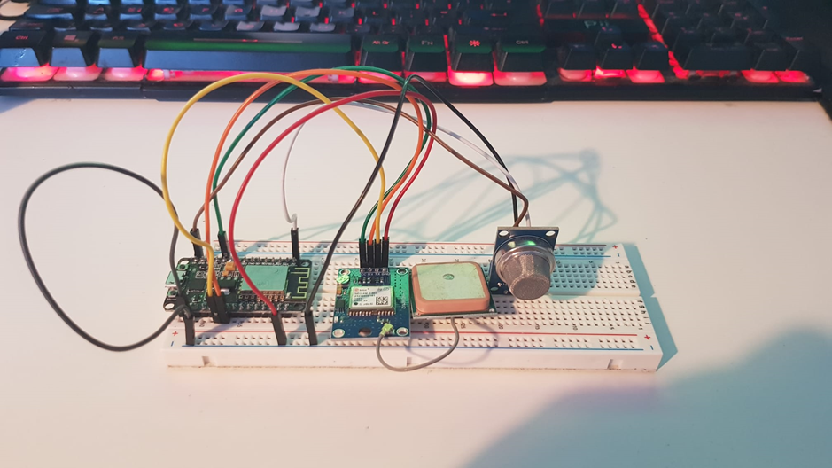

## Circuit Diagram explained:

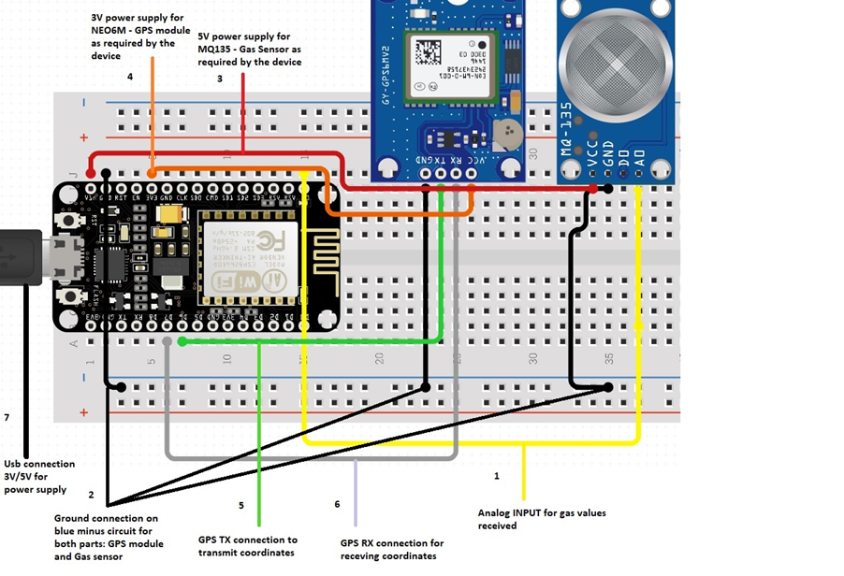

## Software implementation:

After everything was assembled my first step was to use Arduino IDE to create my code to make everything functional as desired and later on to test the functionality on the cloud server. I start by selecting the right **Libraries** and then implementing each one of them including the testing before going forward with another. If I would not test every library which I use this would complicate everything and to adjust and fix the bugs would have taken a much longer time and the code would have not been well indented which result in a low code quality, hard to read and almost impossible to work with.

### I used the following libraries:

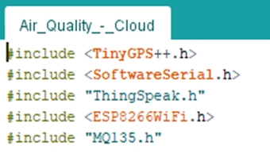

1. **<ThingSpeak.h>**

<ThingSpeak.h> I used to establish the connection with my cloud server where I generated the channels for my device and the API Keys to receive the data.

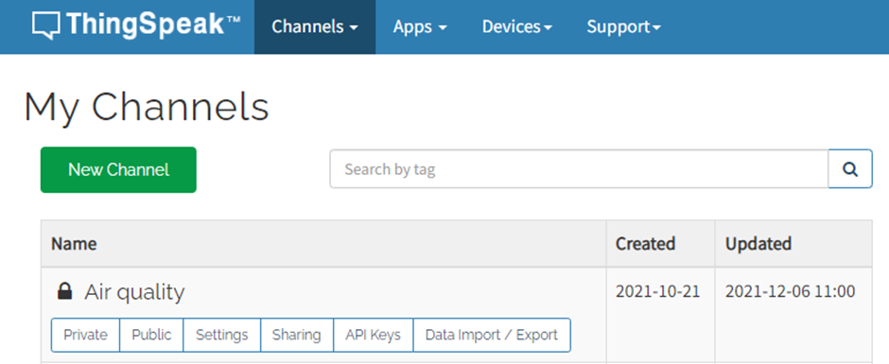

1. **<ESP8266WiFi.h>**

<ESP8266WiFi.h> It’s the wireless connection provided without to connect to a random network for security reasons.



This is the code for network connection and once the connection is establishing the data can be send as well to ThingSpeak Cloud server:

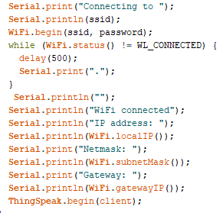

1. **<TinyGPS++.h> and <SoftwareSerial.h>**

<TinyGPS++.h> and <SoftwareSerial.h> to encode the data provided by my GPS module and send it to my cloud server via API key which I generate them in my cloud server. The functionality works based on the instruction below:

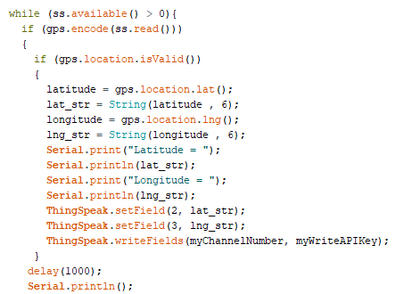

While “ss” (GPS receive and transmit coordinates) it’s bigger than 0 (which mean none null values) proceed further with encoding the data received and if the location it’s valid, than data will be sent to my cloud server in the specified fields with specified API Keys. After the coordinates are given, I’ll display everything on a static map with a view of 50 Meter from above.

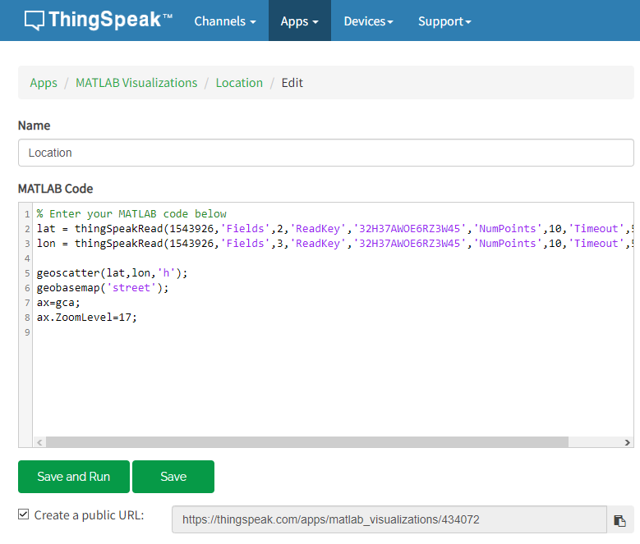

1. **<MQ135.h>**

<MQ135.h> It’s the library for the gas sensor with analog input float values. Once any value it’s registered, the data will be sent in to cloud server in the field 1 (this is what I allocated) and display it on the main page. 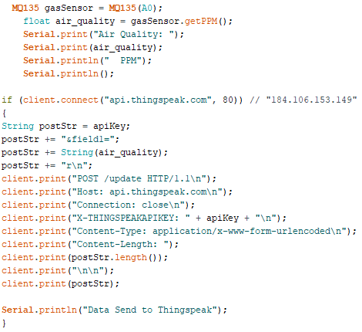

## Final Code (the code provided below its attached in appendices as well):

This is the final code:

#include <TinyGPS++.h>

#include <SoftwareSerial.h>

#include "ThingSpeak.h”

#include <ESP8266WiFi.h>

#include "MQ135.h”

static const int RXPin = 4, TXPin = 5;

static const uint32_t GPSBaud = 9600;

float latitude, longitude;

String lat_str, lng str;

// repace your wifi username and password

String apiKey = "HFTAQCPXIBVTQOH0";

const char* ssid = "Wade"; // Network Name

const char* password = "wade1234"; // Network Password

unsigned long myChannelNumber = 1543926;

const char * myWriteAPIKey = "HFTAQCPXIBVTQOH0";

const char* server = "api.thingspeak.com";

// The TinyGPS++ object

TinyGPSPlus gps;

WiFiClient client;

// The serial connection to the GPS device

SoftwareSerial ss(RXPin, TXPin);

void setup()

{

Serial.begin(115200);

ss.begin(GPSBaud);

Serial.print("Connecting to ");

Serial.println(ssid);

WiFi.begin(ssid, password);

while (WiFi.status() != WL_CONNECTED) {

delay(500);

Serial.print(".");

}

Serial.println("");

Serial.println("WiFi connected");

Serial.println("IP address: ");

Serial.println(WiFi.localIP());

Serial.print("Netmask: ");

Serial.println(WiFi.subnetMask());

Serial.print("Gateway: ");

Serial.println(WiFi.gatewayIP());

ThingSpeak.begin(client);

}

void loop()

{

MQ135 gasSensor = MQ135(A0);

float air_quality = gasSensor.getPPM();

Serial.print("Air Quality: ");

Serial.print(air_quality);

Serial.println(" PPM");

Serial.println();

if (client.connect("api.thingspeak.com", 80)) // "184.106.153.149" or api.thingspeak.com

{

String postStr = apiKey;

postStr += "&field1=";

postStr += String(air_quality);

postStr += "r\n";

client.print("POST /update HTTP/1.1\n");

client.print("Host: api.thingspeak.com\n");

client.print("Connection: close\n");

client.print("X-THINGSPEAKAPIKEY: " + apiKey + "\n");

client.print("Content-Type: application/x-www-form-urlencoded\n");

client.print("Content-Length: ");

client.print(postStr.length());

client.print("\n\n");

client.print(postStr);

Serial.println("Data Send to Thingspeak");

}

while (ss.available() > 0){

if (gps.encode(ss.read()))

{

if (gps.location.isValid())

{

latitude = gps.location.lat();

lat_str = String(latitude , 6);

longitude = gps.location.lng();

lng_str = String(longitude , 6);

Serial.print("Latitude = ");

Serial.println(lat_str);

Serial.print("Longitude = ");

Serial.println(lng_str);

ThingSpeak.setField(2, lat_str);

ThingSpeak.setField(3, lng_str);

ThingSpeak.writeFields(myChannelNumber, myWriteAPIKey);

}

delay(1000);

Serial.println();

}

}

}

## Result and Evaluation

The project it’s a success and everything it working as intended. The main page (admin page) it’s displaying the input with a delay of 15 seconds for a better performance from the GPS module and gas sensor.

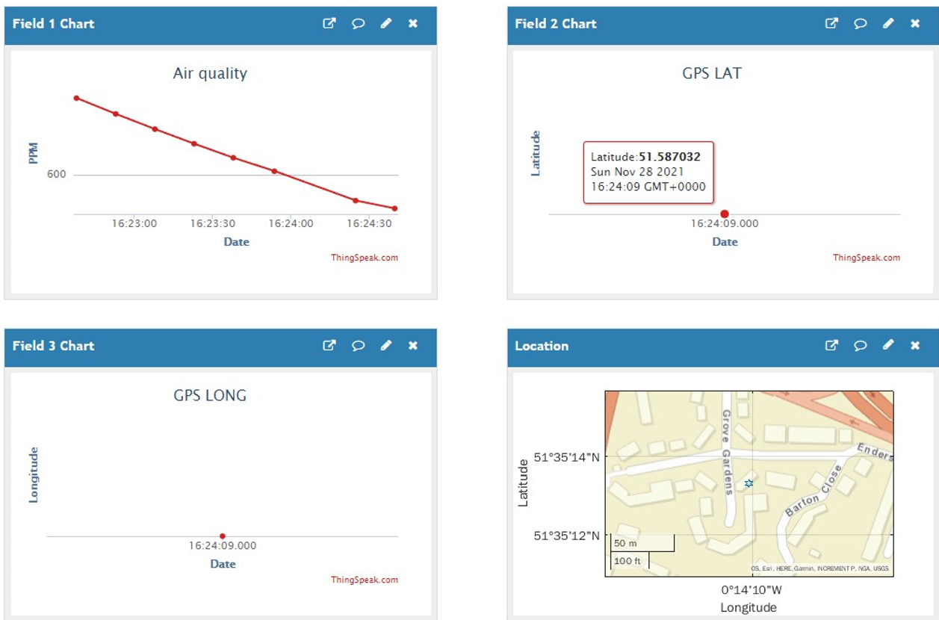

I have 4 graphs and all are required. Even if I display the Location on a graph, I still need the graphs for Latitude and Longitude for data purpose as each input from the Field 1 which is the “Air quality” graph will gone have attached the location as well in case if the data it’s from a mobile data gathering or the device was moved in a different location.

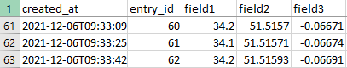

The advantage in using ThingSpeak as cloud server it’s that they provide many futures such as data export. The data can be exported from cloud server and each channel (each device) has its own data export which can be later used as example in creating a moral prediction in python:

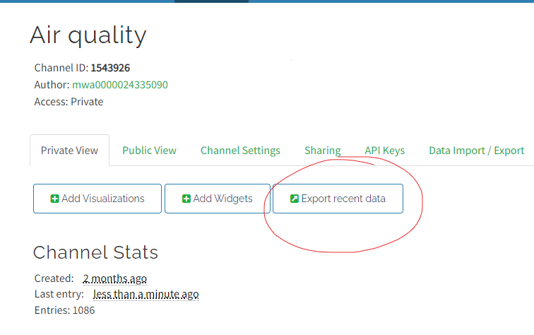

Another future is that I can share a public web page for users or specific users which they can see the page only through link access which can be received through email:

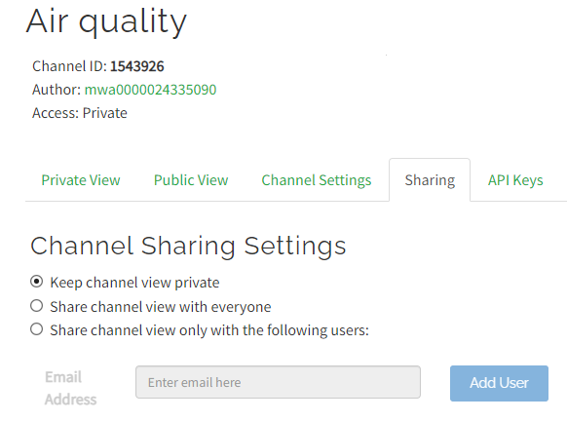

# Conclusion

The project could have more improvements after I tested a lot in special in my early stages for this design. The GPS connection it’s a bit difficult at the begin as sometimes it take even 30-60 min to establish the connection and it need to be done outdoor or if it’s indoor, the device needs to stay close to a window until a satellite will lock in place the location.

I choose the wireless/wi-fi connection for a better quality since I have to work with cloud communication and exporting a lot of data in real time. There are other options for network connection such as GSM.

About the air quality detection, I choose the MQ135 as this sensor can detect multiple gases which are hazardous for living beings and it can be set with a higher sensibility to detect faster other gases.

I used the NodeMCU v1.0 because of the size which it’s a great future and many connections for power supply as in the begin when I tried to provide a power link for my parts, the last device on the link failed to power up and the only solution was to provide other source of power.

Overall, this project it’s a success and it work as designed.

# Future work

There are some improvements which they can be added to this project:

1. GSM 4G/5G connection which will make the device more reliable in terms of placement
2. Adding an SSD to collect data and store it in case the network connection failed and upload the data once the connection it’s regained and recycle the memory
3. Solar panel with battery to improve even more the portability of the device and the placement
4. A better motherboard for possibility to troubleshoot the device from distance in case of a malfunction
5. Rework the code in Python with the possibility to create an algorithm which can be trained to control the traffic lights based on the data provide from the devices since the data it’s saved in files type .csv
6. Self-destruction (software destruction) in case the device can’t be recovered or not located anymore
7. Add firewall in case the device is hacked through a direct connection (USB connection or other sources)
8. I would use better materials for the construction such as cooper jumper wires for a longer life and a better power management
9. Adding a smart camera for object detection with the capacity to identify what object produced the pollution. As an example, when a car is passing by, the camera will identify how much CO2 was produced by that car. Only for anormal pollution detected

# Reflection on Learning

Thinking back when I made my proposal, I never thought I am gone learn so many things about creating a physical device and I’ve learned even more than that. My networking classes helped me to create my connection to a cloud server and design security measures and many other things which without them I would probably struggle a lot to achieve what I did. IoT classes where really important as I had a lot of practice on different concepts of devices which give me that spark to make me research things which I didn’t need, but are essential for my future career. The programming classes with which I couldn’t build my project, were absolutely great as I’ve learned Java, C#, OOP, SQL and many other languages and the most important was C++ in which I designed my code for this project. Without all those experiences I would probably struggle a lot to finish this project or even fail, but I am glad I made it so far and I am very grateful to my professors for all the knowledge I have now.

# References

Anon., ? - Present. *ArduinoProjectHub.* [Online]   
Available at: https://create.arduino.cc/projecthub  
[Accessed 23 11 2021].

Anon., 2001-present. *How2Electronics.* [Online]   
Available at: https://how2electronics.com  
[Accessed 10 11 2021].

Anon., 2001-present. *IoTDesignPro.* [Online]   
Available at: https://how2electronics.com  
[Accessed 19 11 2021].

Anon., 2021. *TutorialsPoints.* [Online]   
Available at: https://www.tutorialspoint.com/index.htm  
[Accessed 05 11 2021].

Anon., present. *Build Electronics Circuits.* [Online]   
Available at: https://www.build-electronic-circuits.com/how-to-solder/  
[Accessed 27 11 2021].

Components, 2021. *Components101.* [Online]   
Available at: https://components101.com/articles/introduction-to-gas-sensors-types-working-and-applications  
[Accessed 29 12 2021].

Geeksforgeeks, 2022. *Geeksforgeeks.* [Online]   
Available at: https://www.geeksforgeeks.org/top-10-fastest-programming-languages/  
[Accessed 11 02 2022].

MathWorks, 1994-2022. *MathWorks.* [Online]   
Available at: https://uk.mathworks.com/help/thingspeak/getting-started-with-thingspeak.html  
[Accessed 21 11 2021].

WHO, 2021. *World Health Organization.* [Online]   
Available at: https://www.who.int/news-room/fact-sheets/detail/ambient-(outdoor)-air-quality-and-health  
[Accessed 12 11 2021].

Anon., ? - Present. *ArduinoProjectHub.* [Online]   
Available at: https://create.arduino.cc/projecthub  
[Accessed 23 11 2021].

Anon., 2001-present. *How2Electronics.* [Online]   
Available at: https://how2electronics.com  
[Accessed 10 11 2021].

Anon., 2001-present. *IoTDesignPro.* [Online]   
Available at: https://how2electronics.com  
[Accessed 19 11 2021].

Anon., 2021. *TutorialsPoints.* [Online]   
Available at: https://www.tutorialspoint.com/index.htm  
[Accessed 05 11 2021].

Anon., present. *Build Electronics Circuits.* [Online]   
Available at: https://www.build-electronic-circuits.com/how-to-solder/  
[Accessed 27 11 2021].

Components, 2021. *Components101.* [Online]   
Available at: https://components101.com/articles/introduction-to-gas-sensors-types-working-and-applications  
[Accessed 29 12 2021].

Geeksforgeeks, 2022. *Geeksforgeeks.* [Online]   
Available at: https://www.geeksforgeeks.org/top-10-fastest-programming-languages/  
[Accessed 11 02 2022].

MathWorks, 1994-2022. *MathWorks.* [Online]   
Available at: https://uk.mathworks.com/help/thingspeak/getting-started-with-thingspeak.html  
[Accessed 21 11 2021].

WHO, 2021. *World Health Organization.* [Online]   
Available at: https://www.who.int/news-room/fact-sheets/detail/ambient-(outdoor)-air-quality-and-health  
[Accessed 12 11 2021].

# Appendices

### Logbooks:

   ********************

### Ethical Form:



### Power Point Presentation



### Arduino Code

